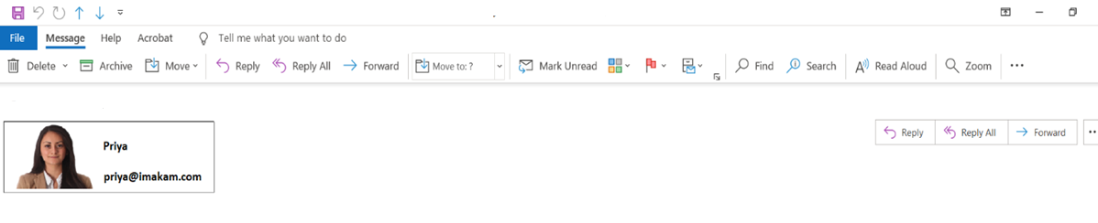

Calgary Transit

Can you email Bob and tell him that I need more time for my part of the presentation? Ugh I can’t stand public speaking, but I guess it won’t be as bad for the virtual thing. I need him to contribute more data on the awards. Please let me know when you hear back from him.

From Priya, Director of Operations.

Here is Bobs email [bob@imakam.com](mailto:bob@imakam.com) and phone number (403) 234-5678. Bob manager at Marketing

**Priya**  
**Director of Operations**  
403-234-5678  
123 MaKami Street  
Calgary, AB A1B 2C3  
[priya@imakam.com](mailto:priya@imakam.com)

Thanks,